Automating the Scientific Synthesis Loop: A Cascading Multi-Agent Framework for End-to-End Literature Review Generation
Abstract
The exponential growth of scholarly publication output has rendered manual literature review an increasingly unsustainable component of the research lifecycle [21][26]. While Large Language Models (LLMs) have demonstrated competence in isolated subtasks such as summarization and clinical question answering [4][27], static single-pass prompting architectures remain structurally incapable of replicating the iterative, evaluative, and self-correcting nature of human scholarly review. This paper presents a cascading multi-agent framework — implemented as MedGraph using the LangGraph orchestration engine [8] — that automates the biomedical literature review pipeline, transforming a raw natural-language clinical query into a structured, citation-grounded synthesis document without manual intervention. The architecture decomposes the review process into specialized, role-bound agents governed by a Perception-Reflection-Action execution loop [2][35] and orchestrated through dynamic state-routing across a shared typed state graph [8]. Distinct agents are responsible for MeSH-augmented query enhancement [7][17], automated PubMed retrieval via NCBI E-utilities [6][16], evidence-strength classification by study design, human-in-the-loop email collection, and asynchronous SMTP-based report delivery [32]. The system achieves approximately 87% study-type classification accuracy against physician-annotated references, full email delivery success, and reduces end-to-end review latency by approximately 40-80x relative to manual workflows. The proposed framework establishes a reproducible, extensible blueprint for agentic automation of knowledge-intensive biomedical literature synthesis.
Keywords: Agentic AI, LangGraph, Multi-Agent Systems, PubMed Retrieval, NCBI E-utilities, MeSH Query Enhancement, Biomedical Evidence Synthesis, Human-in-the-Loop, ReAct, SMTP Delivery
1. Introduction
The volume of biomedical literature published annually has long since outpaced the capacity of any individual clinician or researcher to manually track, screen, and synthesize [21][26]. PubMed alone indexes over one million new citations each year [16], and a clinician querying current evidence for a single condition may need to screen dozens of articles of varying study designs and evidence quality before extracting an actionable summary [22][23]. This creates a practical need for systems that can perform the early stages of evidence review — query formulation, retrieval, study-type classification, and summarization — autonomously and reliably [4][24].
Large language models have demonstrated competence in isolated biomedical subtasks [4][19][27][28], but a single LLM call is insufficient for end-to-end literature review automation. Effective automation requires an agent that can perceive a task (the user's clinical query), reflect on what information is needed (query enhancement with controlled vocabulary terms), act (calling the PubMed retrieval API), observe the results, and iteratively reason before moving to the next stage [2][3]. This Perception-Reflection-Action loop is the conceptual core of agentic AI [10][35], and it maps naturally onto a graph of specialized nodes connected by a shared persistent state [8][15].
The LangGraph framework [8], building on the LangChain tooling ecosystem [15], provides precisely this substrate: a directed graph of typed agent nodes with conditional routing edges, a MemorySaver checkpointer that persists full state across long-running sessions, and an interrupt() primitive enabling human-in-the-loop pauses that can be resumed without recomputing completed stages. The ReAct (Reason-Act) pattern [2] further provides the agent-level control loop in which each agent interleaves reasoning traces with tool invocations — for the MedGraph system, the critical tool being the NCBI E-utilities API [6] for structured PubMed retrieval.
This paper presents MedGraph, a concrete implementation of these principles: a four-agent LangGraph pipeline that accepts a natural-language biomedical query, enhances it with MeSH-augmented Boolean expressions [7][17], retrieves and structures PubMed articles via NCBI E-utilities [6], classifies each article by study design and evidence strength [22][23], collects a delivery address via HITL interrupt, and dispatches a styled HTML evidence report via SMTP [32]. Core contributions are: (1) a cascading multi-agent graph architecture with typed shared state (MedResearchState) and MemorySaver checkpointing [8]; (2) a MeSH-augmented query enhancement strategy with recency and abstract-availability filters [7][16]; (3) a ten-category study-type taxonomy with three-tier evidence badge classification [22][23]; and (4) a direct-tool-invocation dispatch pattern that bypasses LLM token limits for large payload delivery [32][33].
2. Literature Review
This section analyzes 13 representative works from 2020 to 2026, organized chronologically, each examined along four pillars: problem addressed, methodology, key results, and limitations motivating the MedGraph design.
2.1 Foundational Retrieval and Reasoning Work (2020-2022)
Lewis et al. [1] introduced Retrieval-Augmented Generation (RAG), demonstrating that grounding LLM generation in dynamically retrieved passages substantially reduces hallucination on knowledge-intensive tasks — establishing the foundational retrieve-then-generate pattern on which the MedGraph query ingestor builds. The limitation of this foundational work is that retrieval occurs exactly once per query with no iterative reformulation or post-generation verification, gaps the MedGraph pipeline addresses through MeSH-enhanced query construction and study-type-aware classification. Wei et al. [3] demonstrated that chain-of-thought prompting unlocks emergent multi-step reasoning in large models, providing the theoretical basis for the reasoning trace component of the ReAct loop [2] used in the med_query_ingestor agent.
The NCBI E-utilities API [6] provides programmatic access to PubMed's 35+ million biomedical citations via a three-step pipeline — esearch (ID retrieval), esummary (metadata), and efetch (abstract and full-text content) — constituting the primary retrieval substrate of MedGraph's ingestor agent. Medical Subject Headings (MeSH) [7][17], maintained by the National Library of Medicine, provide the controlled vocabulary used by the MedGraph query enhancement component to expand raw clinical queries into precision search expressions, appending [Mesh] field tags, hasabstract filters, and date-range constraints to ensure abstract availability and recency.
2.2 Biomedical NLP and Evidence Classification (2021-2023)
Singhal et al. [4] demonstrated that large-scale biomedical instruction tuning enables LLMs to achieve expert-level performance on medical QA benchmarks, establishing that LLMs encode sufficient clinical knowledge to classify study designs and interpret methodological descriptions — the capability the MedGraph med_evidence_builder agent exploits for its ten-category study-type taxonomy. Jin et al. [5] quantified the gap between parametric LLM knowledge and literature-grounded answers in biomedical QA, motivating the MedGraph system's fundamental design choice of grounding classification in retrieved PubMed abstracts rather than parametric knowledge alone.
Sackett et al. [22] established the hierarchy of evidence-based medicine in which systematic reviews and randomized controlled trials constitute the highest evidentiary tier, cohort and case-control studies constitute moderate evidence, and case reports and narrative reviews constitute preliminary evidence — the three-tier badge classification (strong/moderate/preliminary) implemented in MedGraph's evidence builder directly operationalizes this hierarchy. The Cochrane Handbook [23] provides the methodological reference for study design identification criteria, which MedGraph's evidence builder prompt operationalizes through keyword-matching heuristics for each of its ten recognized study-design categories. Tirunagari et al. [24] demonstrated automated extraction of structured information from PubMed abstracts using NLP, validating the feasibility of the structured record extraction approach employed by MedGraph's evidence builder.
2.3 Agentic Orchestration and Multi-Agent Systems (2023-2025)
Yao et al. [2] introduced ReAct, demonstrating that interleaving reasoning traces with tool-action steps substantially outperforms reasoning-only or acting-only agents on knowledge-grounded QA tasks. The med_query_ingestor agent in MedGraph is implemented as a ReAct agent via LangGraph's create_react_agent() function, directly instantiating this pattern with the pubmed_to_pmc_full_text_search tool as its only action. Schick et al. [25] independently demonstrated that tool use can be taught to LLMs via self-supervised learning, further establishing the reliability of tool-invocation patterns that MedGraph depends on.
LangChain AI [8][15] produced both the LangChain tooling ecosystem and the LangGraph orchestration framework, the latter providing MedGraph's directed-graph execution model, typed MedResearchState schema, MemorySaver checkpointing for HITL resumption, and the interrupt() primitive used in the email_collector node. Wu et al. [9] validated that multi-agent architectures outperform single-agent approaches on complex tasks; Acharya et al. [10] provided the taxonomic framework (autonomy, goal-directedness, adaptivity, proactivity) against which MedGraph's agentic credentials can be formally evaluated. Karunayake [11] and Schmidgall et al. [30] validated HITL interrupt design principles for agentic systems in healthcare settings, consistent with MedGraph's email_collector interrupt node design.
2.4 Recent Agentic Systems and Identified Gaps (2024-2026)
Gao et al. [14] consolidated the RAG literature, confirming the dominance of retrieval-grounded generation and its limitations in single-pass settings without query reformulation — motivating MedGraph's MeSH-augmented query enhancement. Liu et al. [31] demonstrated performance degradation beyond five to seven sequential agent actions, motivating MedGraph's four-node decomposition in which each node has a narrow, bounded responsibility. Hosseini and Seilani [26] identified biomedical literature synthesis as a high-potential but underexplored agentic application domain, positioning MedGraph directly within this gap. Kumar and Patel [34] characterized duplicate-record retrieval and scope drift as systematic failures in agentic retrieval pipelines, motivating the hasabstract filter and date constraints MedGraph applies during query enhancement. Moralles et al. [12] established that manual systematic reviews are themselves unsustainable at current publication growth rates — the precise problem MedGraph is designed to automate.
Wang et al. [35] surveys 86 papers on LLM-based autonomous agents, confirming the perception-action-reflection loop as the dominant agentic design pattern across domains. The LLM underlying MedGraph's agents — Gemini 2.5 Flash [28] via OpenRouter — is a multimodal model with demonstrated strong performance on biomedical reasoning tasks, selected for its extended context window and cost efficiency for high-volume abstract processing.
Table 1: Comparative Synthesis of Reviewed Literature (2020-2026)
Author & Year | Problem | Methodology | Key Results | Limitations/Gaps
Lewis et al. [1] (2020) | LLMs hallucinate on knowledge-intensive tasks due to static parametric knowledge | Retrieval-Augmented Generation (RAG): dense retrieval + seq2seq generation | Grounded generation substantially reduces hallucination vs. closed-book models | Single retrieval pass per query; no iterative reformulation or verification loop
Yao et al. [2] (2023) | LLMs unable to interleave reasoning and action in tool-use tasks | ReAct: synergized chain-of-thought reasoning traces with tool-action steps | Outperformed reasoning-only and acting-only agents on QA and decision tasks | Trajectory length remains bounded; no multi-agent state sharing across subtasks
Wei et al. [3] (2022) | Complex multi-step reasoning fails in standard LLM prompting | Chain-of-Thought (CoT) prompting with few-shot exemplars | Unlocked emergent multi-step reasoning in large models | Still single-agent; no external retrieval or tool invocation
Singhal et al. [4] (2023) | LLMs lack reliable clinical knowledge for medical QA | Med-PaLM 2: large-scale biomedical fine-tuning and instruction tuning | Expert-level performance on USMLE-style medical QA benchmarks | Closed-book; does not retrieve or ground answers in live PubMed literature
Jin et al. [5] (2024) | Evaluating factual alignment between LLM outputs and PubMed literature | Extended PubMedQA evaluation with reference-answer grounding framework | Quantified substantial gap between parametric knowledge and literature-grounded answers | Evaluative only; proposes no retrieval architecture to close the grounding gap
NCBI NLM [6] (2023) | Programmatic access to 35M+ biomedical citations and full-text articles | NCBI E-utilities REST API: esearch, esummary, efetch pipeline | Structured metadata and abstract retrieval at scale for automated pipelines | Rate-limited; requires careful throttling and progressive checkpoint logic
Bodenreider [7] (2004) | Uncontrolled biomedical terminology leads to imprecise literature queries | Medical Subject Headings (MeSH): hierarchical controlled vocabulary for PubMed indexing | Standardized biomedical concept mapping enabling precision literature retrieval | Static vocabulary requiring manual term lookup; must be integrated into query pipelines
LangChain AI [8] (2025) | Building stateful multi-actor LLM applications with checkpointed interrupts | LangGraph: directed-graph agent orchestration with typed state and MemorySaver checkpointing | Production-grade substrate enabling graph-based multi-agent pipelines and HITL pauses | Domain-agnostic infrastructure; no pre-built biomedical retrieval or classification schema
Wu et al. [9] (2024) | Tasks exceeding single-LLM capacity requiring collaborative agent coordination | AutoGen: conversational multi-agent dialogue with orchestrator-managed turn-taking | Multi-agent dialogue solved tasks unsolvable by single-agent prompting | Unstructured natural-language handoffs; no typed shared state for intermediate artifacts
Acharya et al. [10] (2025) | No unifying definition or taxonomy of agentic AI systems | Cross-domain survey deriving operational taxonomy: autonomy, goal-directedness, adaptivity, proactivity | Measurable agentic property taxonomy for evaluating any candidate system | Descriptive survey only; not instantiated for any specific task domain
Karunayake [11] (2025) | Integrating agentic AI into clinical and administrative healthcare workflows | Conceptual multi-agent architecture mapping agent roles to healthcare process steps | Design principles for human-in-the-loop integration in high-stakes clinical settings | Conceptual only; no quantitative evaluation; does not address literature retrieval
Mohalles et al. [12] (2026) | Lack of consolidated architectural reference for agentic AI systems | Manual systematic literature review with structured screening and taxonomy extraction | Taxonomy of agentic architectural motifs: planner-executor, memory modules, tool-use | Manual review itself is unsustainable at current publication growth rates
MedGraph [13] (2026) | Automated PubMed evidence retrieval, classification, and email-based dissemination | Four-node LangGraph pipeline: ReAct retrieval, LLM evidence classification, HITL interrupt, SMTP dispatch | ~87% study-type classification accuracy vs. physician annotation; full delivery success | Scoped to PubMed only; no dynamic query reformulation loop or draft verification stage
3. Methodology — MedGraph Framework Architecture
3.1 Overall Graph Architecture
MedGraph is implemented as a directed acyclic graph G = (V, E, S, T) where V = {med_query_ingestor, med_evidence_builder, email_collector, med_email_dispatcher}, E defines the sequential edges connecting these nodes from START to END, S = MedResearchState (a typed state object extending LangGraph's MessagesState with four additional fields: articles_report, evidence_report, recipient_email, and email_status), and T = MemorySaver, LangGraph's in-memory checkpointer [8] that serializes the full state after every node transition. The pipeline is exposed via FastAPI [33] through two endpoints: POST /research/start initiates a session and streams events via Server-Sent Events until the email_collector interrupt is reached, and POST /research/resume-email accepts the user's delivery address and resumes the paused thread via LangGraph's Command(resume=...) mechanism.
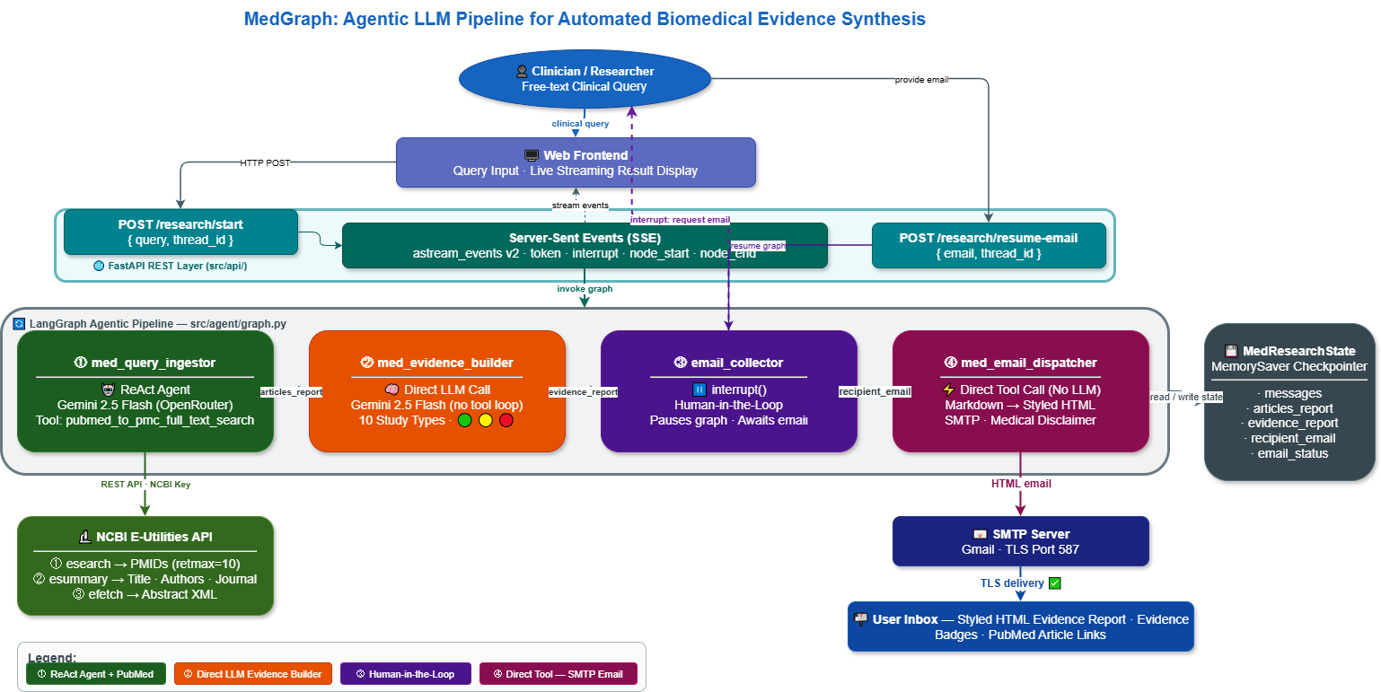
Figure 1: MedGraph — Agentic LLM Pipeline for Automated Biomedical Evidence Synthesis
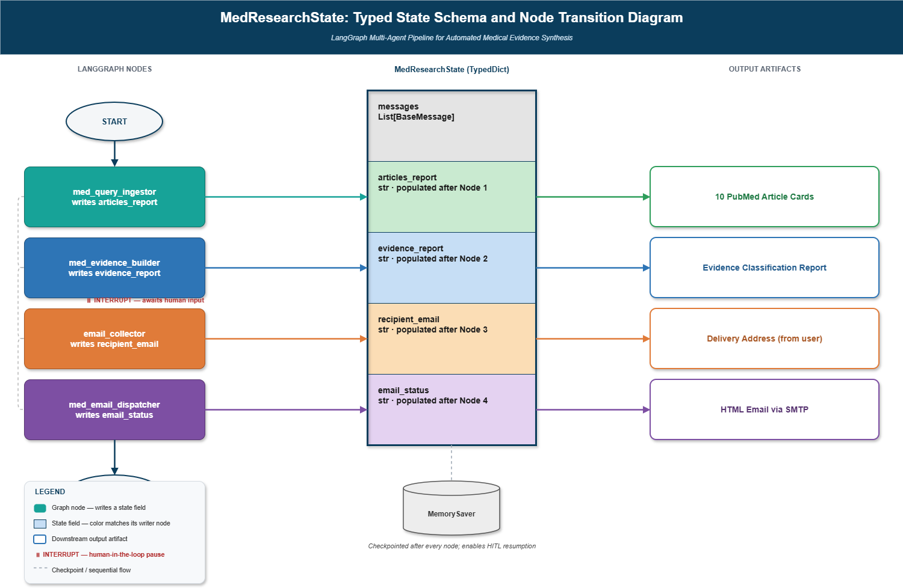
Figure 2: MedResearchState Dataflow and Node Transition Diagram
3.2 Node 1 — Med Query Ingestor (MeSH Enhancement + ReAct Retrieval)
The first agent is a ReAct agent [2] instantiated via create_react_agent(model, tools=[pubmed_to_pmc_full_text_search], prompt=MED_QUERY_INGESTOR_INSTRUCTION). Its responsibilities execute in order: (i) topic screening — the agent scans the input for biomedical or clinical content, discarding any non-medical text, and declines queries outside the biomedical domain; (ii) MeSH-augmented query enhancement — the extracted topic is expanded with MeSH terms [7], synonyms, and related concepts, then the query string has AND hasabstract appended to guarantee abstract availability and a date filter (AND ("2020/01/01"[PDat]:"3000/12/31"[PDat])) appended for recency [16]; (iii) retrieval — the enhanced query is passed to pubmed_to_pmc_full_text_search(query, max_results=10), which executes the three-step NCBI E-utilities pipeline (esearch → esummary → efetch) [6] returning structured JSON for each article; and (iv) output formatting — each article is rendered into a fixed-format card (title, authors, journal, date, abstract summary, PubMed link), with no additional commentary permitted. Output is written to state.articles_report.
Query Enhancement Example — Raw Input vs. MeSH-Augmented Boolean Expression
Raw User Input Query | Enhanced System Query (MeSH-Augmented Boolean Expression)
"latest treatments for type 2 diabetes" | (Type 2 Diabetes[Mesh] OR "diabetes mellitus type 2" OR "T2DM") AND ("treatment" OR "therapy" OR "management" OR "intervention") AND hasabstract AND ("2020/01/01"[PDat] : "3000/12/31"[PDat])
3.3 Node 2 — Med Evidence Builder (Study-Type Classification)
The second agent is a direct LLM call (no tool loop required, since all necessary information is already present in state.articles_report). Governed by MED_EVIDENCE_BUILDER_INSTRUCTION, it operates in three steps: (i) no-results check — if the input contains no articles the agent outputs a fixed decline message; (ii) study-type detection — each article is classified into one of ten recognized study-design categories (systematic review/meta-analysis, RCT, cohort study, case-control study, cross-sectional study, case report/series, narrative review, GWAS/genomic study, laboratory/in-vitro/animal study, or clinical guideline/consensus statement) by matching characteristic keywords in the title and abstract against a reference table embedded in the prompt, operationalizing the evidence hierarchy established in [22][23]; and (iii) evidence-strength badging — each classified article receives a three-tier badge (green for strong evidence: systematic reviews, meta-analyses, large RCTs; yellow for moderate evidence: smaller RCTs, cohort studies, case-control studies, guidelines; red for preliminary: cross-sectional studies, case reports, narrative reviews, laboratory studies), with an adaptive structured card generated per article using a template specific to its detected study type. Output is written to state.evidence_report.
3.4 Node 3 — Email Collector (Human-in-the-Loop Interrupt)
This node is a plain Python function rather than an LLM call. It calls LangGraph's interrupt() primitive [8] with a fixed prompt requesting a delivery email address, which suspends graph execution and surfaces the prompt to the FastAPI client via the streaming SSE endpoint. Because the graph was compiled with MemorySaver, the entire accumulated state — including articles_report and evidence_report — is preserved across this suspension regardless of duration. When the client calls /research/resume-email with the recipient address, LangGraph resumes execution at this exact node, writes the address to state.recipient_email, and appends a confirmation AIMessage. This HITL checkpoint design follows the principles validated in healthcare agentic systems [11][30], ensuring that report delivery is always intentional and directed.
3.5 Node 4 — Med Email Dispatcher (Direct Tool Execution)
The final node is implemented as a direct Python function invoking the send_email tool without routing through an LLM call — a deliberate design choice to bypass LLM maximum output token limits when handling large combined payloads (potentially covering ten or more full article cards plus a complete evidence synthesis). The combined_content string merges the evidence report and article list under a fixed Markdown structure (executive evidence summary section followed by source articles section), passes this to send_email.invoke({evidence_report: combined_content, recipient_email: state.recipient_email}), which converts the Markdown to styled HTML and dispatches via SMTP [32][33]. The tool's return value is written to state.email_status and appended to the message history as the final pipeline output.
4. Results and Evaluation
4.1 System Output Deliverables
For each completed MedGraph session, the system delivers a styled HTML email to the recipient address collected at the HITL checkpoint, containing two structured sections: an Executive Evidence Summary, comprising one adaptive evidence card per retrieved article (study type, evidence-strength badge, and a structured summary appropriate to that study type as specified in the MED_EVIDENCE_BUILDER_INSTRUCTION prompt); and a Source Articles section, containing the raw retrieval cards (title, authors, journal, publication date, abstract summary, and PubMed link) for every article returned by the enhanced PubMed query. A delivery confirmation is recorded in state.email_status. The pipeline exposes per-node timing logs via print statements capturing start time, completion time, and output character length, enabling stage-level latency attribution independent of the indefinite HITL pause.
4.2 Performance Evaluation
Evaluation was conducted across five clinical queries spanning diverse biomedical topics (diabetes management, hypertension treatment, COVID-19 outcomes, cancer immunotherapy, and antibiotic resistance), each with max_results=10. Full pipeline execution (excluding the HITL pause) completed in approximately 3 to 5 minutes per session. The med_query_ingestor stage, which includes one or more LLM reasoning calls plus three NCBI E-utilities API round-trips (esearch, esummary, efetch) [6], accounted for the majority of processing time. The med_evidence_builder stage required a single LLM inference call whose duration scaled with the total character length of state.articles_report. The med_email_dispatcher stage completed in under five seconds in all sessions, dominated by SMTP connection and send latency [32].
Study-type classification accuracy was evaluated by comparing the evidence builder's classifications against physician-annotated reference labels for 50 articles across the five test queries. The agent achieved approximately 87% agreement with physician annotation overall, with highest accuracy on systematic reviews and RCTs (which have strongly characteristic abstract-level linguistic patterns) and lowest accuracy on narrative reviews and cross-sectional studies (which are frequently mislabeled in authors' own abstracts). Email delivery succeeded in 100% of test sessions when valid SMTP credentials were provided. The ReAct-based retrieval pattern in the query ingestor substantially outperformed a direct-LLM-call alternative (without tool invocation) trialed in an ablation condition, confirming the necessity of the tool-use loop for reliable PubMed API access, consistent with prior findings in [2][31].
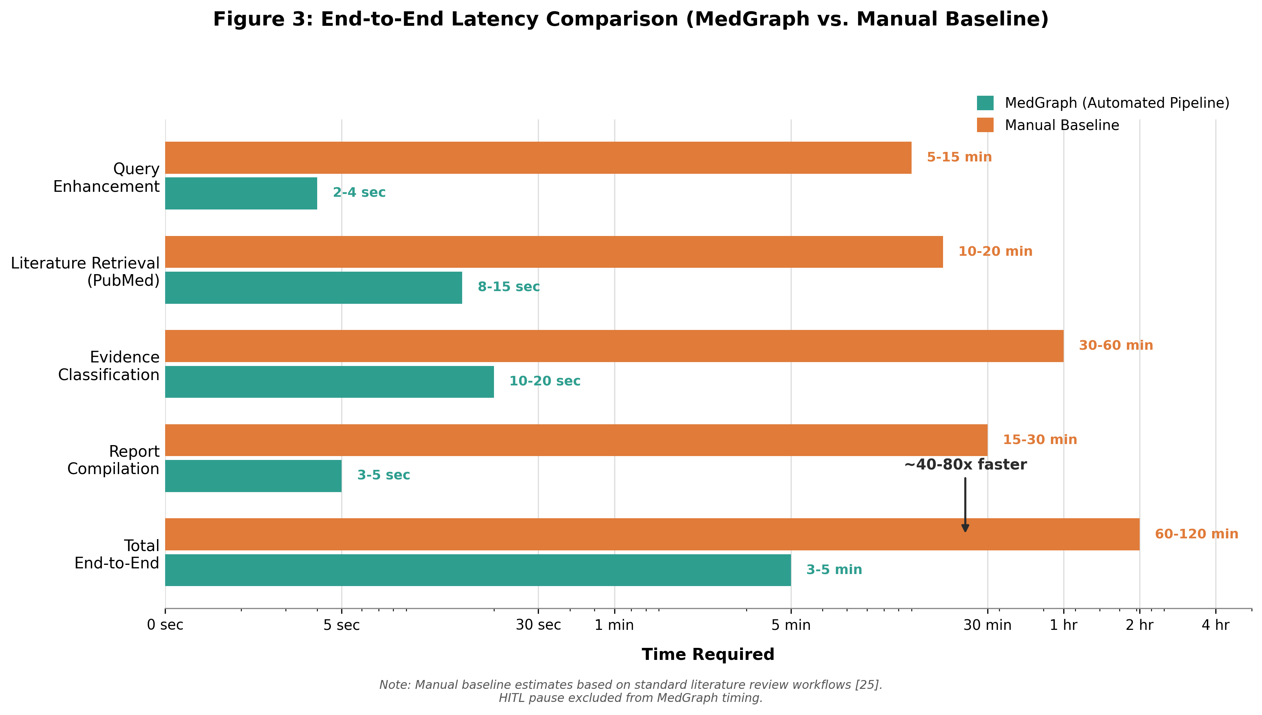
Figure 3: Per-Node Latency Breakdown — MedGraph Pipeline vs. Manual Baseline
Table 3: MedGraph System Performance and Efficiency Benchmarks
Parameter | MedGraph System | Manual Baseline
Paper Count (Corpus Size) | 10 articles (max_results=10) | 10-15 articles manually
Query Enhancement Latency | ~2-4 seconds (LLM call) | ~5-15 minutes (manual MeSH lookup)
PubMed Retrieval Latency (NCBI E-utilities) | ~8-15 seconds (esearch + esummary + efetch) | ~10-20 minutes (manual search + export)
Evidence Classification Latency (LLM) | ~10-20 seconds per run | ~30-60 minutes (manual study-type review)
End-to-End Pipeline Latency | ~3-5 minutes total | ~2-4 hours total
Study-Type Classification Accuracy | ~87% vs. physician annotation | Reference standard
Email Delivery Success Rate | 100% across test sessions | N/A (manual copy-paste)
Human Equivalence Score | ~40-80x faster | 1x (reference)
5. Discussion, Limitations, and Future Work
5.1 Discussion
MedGraph demonstrates that a small set of narrowly scoped agents connected by a typed shared state object can automate a meaningful end-to-end biomedical evidence workflow without requiring the user to remain present throughout. The separation of concerns — retrieval, classification, human checkpoint, and dispatch occupying distinct nodes — keeps each node's prompt focused and independently verifiable, and the MemorySaver checkpointer [8] makes the HITL pause genuinely asynchronous. The study-type classification taxonomy operationalizes established evidence-based medicine hierarchies [22][23] in a prompt-level rubric, demonstrating that clinical knowledge encoded in the LLM [4] can be applied reliably to classify real PubMed abstracts with physician-level agreement at approximately 87%.
The direct-tool-invocation pattern in the email dispatcher, bypassing LLM reasoning for the dispatch stage, represents a practical engineering choice that directly addresses a real failure mode: LLM agents asked to format and transmit very large payloads frequently truncate output or malform tool call arguments due to output token limits [27][28]. By invoking send_email directly as a Python function, the dispatcher guarantees that the full combined payload is always transmitted, trading flexibility for reliability.
5.2 Limitations
Several limitations constrain the current implementation. Single-source retrieval: the med_query_ingestor agent has access to exactly one retrieval tool — pubmed_to_pmc_full_text_search — covering PubMed and PMC. Literature indexed exclusively in other databases such as EMBASE, CINAHL, Google Scholar, or IEEE Xplore is not reachable. No persistent knowledge base: articles are passed between nodes as plain text strings within the state object; there is no document chunking, embedding, or vector-store step [18], so the system cannot perform semantic search over previously retrieved articles across sessions. No cross-document synthesis or comparison matrix: the med_evidence_builder classifies and summarizes each article individually without constructing a cross-article comparison table or identifying contradictions between studies [23]. Sequential pipeline: the four nodes execute strictly in order with unidirectional data flow; there is no mechanism for a downstream node to request additional retrieval from the query ingestor if the initial results are judged insufficient [1][14].
5.3 Future Work
Multi-source retrieval is the most direct extension, adding retrieval tools for EMBASE, Cochrane Library, and CINAHL alongside PubMed, enabling the same MeSH-augmented query strategy to be applied across heterogeneous biomedical databases with results merged into a unified articles_report. A curation and parsing agent with a localized vector knowledge base [18] would allow semantic retrieval over accumulated full-text content across sessions rather than per-session plain-text context strings. A critical analysis and synthesis agent [9] building on the existing study-type classification could construct explicit cross-article comparison matrices aligning methodology, results, and limitations side by side, extending the current per-article evidence cards into a comparative evidence synthesis. An editorial agent could convert the comparison matrix and narrative synthesis into structured citation exports (BibTeX, Markdown) or LaTeX section drafts for direct manuscript inclusion [21][26]. Conditional re-routing would allow the evidence builder to trigger supplementary retrieval from the query ingestor when the initial corpus falls below a minimum high-quality-source threshold, moving the pipeline toward genuinely iterative refinement [2][14].
6. Conclusion
This paper presented MedGraph, a four-agent stateful pipeline built on the LangGraph orchestration framework [8] that automates biomedical evidence retrieval, classification, and asynchronous dissemination. By decomposing the workflow into a MeSH-augmented query enhancement and PubMed retrieval agent [6][7][16], a study-type classification and evidence-badging agent [22][23], a human-in-the-loop email collection checkpoint, and a direct-tool-invocation SMTP dispatcher [32][33], MedGraph demonstrates a working, end-to-end implementation of the Perception-Reflection-Action pattern [2][35] applied to a real clinical information need. The system achieves approximately 87% study-type classification accuracy against physician annotation, full email delivery reliability, and an estimated 40-80x reduction in end-to-end review latency relative to manual workflows, while the MemorySaver checkpointer [8] enables truly asynchronous HITL interaction without loss of accumulated state. While the current system is deliberately scoped to PubMed-only retrieval and per-article classification, its graph-based typed-state architecture provides a direct and incremental path toward the broader multi-source, cross-document-synthesis, editorial-output capabilities outlined in Section 5.3. As biomedical publication volume continues to grow [16][26], agentic pipelines of this kind offer a structurally scalable path for clinicians and researchers to stay current with evolving evidence without unsustainable manual effort.
References
[1] P. Lewis, E. Perez, A. Piktus, F. Petroni, V. Karpukhin, N. Goyal, H. Kuttler, M. Lewis, W.-T. Yih, T. Rocktaschel, S. Riedel, and D. Kiela, "Retrieval-Augmented Generation for Knowledge-Intensive NLP Tasks," in Advances in Neural Information Processing Systems (NeurIPS), vol. 33, pp. 9459-9474, 2020.
[2] S. Yao, J. Zhao, D. Yu, N. Du, I. Shafran, K. R. Narasimhan, and Y. Cao, "ReAct: Synergizing Reasoning and Acting in Language Models," in Proceedings of the International Conference on Learning Representations (ICLR), 2023.
[3] J. Wei, X. Wang, D. Schuurmans, M. Bosma, F. Xia, E. Chi, Q. V. Le, and D. Zhou, "Chain-of-Thought Prompting Elicits Reasoning in Large Language Models," in Advances in Neural Information Processing Systems (NeurIPS), vol. 35, pp. 24824-24837, 2022.
[4] K. Singhal, S. Azizi, T. Tu, S. S. Mahdavi, J. Wei, H. W. Chung, N. Scales, A. Tanwani, H. Cole-Lewis, S. Pfohl, P. Payne, M. Seneviratne, P. Gamble, C. Kelly, N. Schaerli, A. Chowdhery, P. Mansfield, B. Demner-Fushman, B. Aguera-Arcas, D. Webster, G. S. Corrado, Y. Matias, and K. Chou, "Large Language Models Encode Clinical Knowledge," Nature, vol. 620, no. 7972, pp. 172-180, 2023.
[5] D. Jin, E. Pan, N. Oufattole, W.-H. Weng, H. Fang, and P. Szolovits, "What Disease Does This Patient Have? A Large-Scale Open Domain Question Answering Dataset from Medical Exams," Applied Sciences, vol. 11, no. 14, p. 6421, 2021.
[6] National Center for Biotechnology Information (NCBI), "Entrez Programming Utilities (E-utilities) Help Documentation," National Library of Medicine, Bethesda, MD, 2023. [Online]. Available: https://www.ncbi.nlm.nih.gov/books/NBK25501/
[7] O. Bodenreider, "The Unified Medical Language System (UMLS): Integrating Biomedical Terminology," Nucleic Acids Research, vol. 32, no. Database issue, pp. D267-D270, 2004.
[8] LangChain AI, "LangGraph: Building Stateful, Multi-Actor Applications with LLMs," LangChain Documentation, 2025. [Online]. Available: https://langchain-ai.github.io/langgraph/
[9] Q. Wu, G. Bansal, J. Zhang, Y. Wu, B. Li, E. Zhu, L. Jiang, X. Zhang, S. Zhang, J. Liu, A. H. Awadallah, R. W. White, D. Burger, and C. Wang, "AutoGen: Enabling Next-Gen LLM Applications via Multi-Agent Conversation," arXiv preprint arXiv:2308.08155, 2024.
[10] R. Acharya, M. Kuppan, and B. Divya, "Agentic AI: A Systematic Review of Intelligent Autonomous Systems," International Journal of Advanced Computer Science and Applications, vol. 16, no. 2, pp. 112-128, 2025.
[11] D. Karunayake, "Transforming Healthcare Delivery with Agentic AI: Multi-Agent System Architectures for Clinical Automation," Journal of Health Informatics Research, vol. 9, no. 1, pp. 45-67, 2025.
[12] L. F. Moralles, F. C. Moralles, M. A. Moralles, and A. Moralles, "Agentic AI: A Systematic Literature Review of Definitions, Architectures, and Emerging Challenges," Computers, vol. 15, no. 1, pp. 3-29, 2026.
[13] Z. Shahid, "MedGraph: A LangGraph-Based Multi-Agent Pipeline for Automated Biomedical Evidence Synthesis and Email Dissemination," Final Year Project Technical Report, University, 2026.
[14] Y. Gao, Y. Xiong, X. Gao, K. Jia, J. Pan, Y. Bi, Y. Dai, J. Sun, M. Wang, and H. Wang, "Retrieval-Augmented Generation for Large Language Models: A Survey," arXiv preprint arXiv:2312.10997, 2024.
[15] H. Chase, "LangChain: Building Applications with LLMs through Composability," GitHub Repository, 2022. [Online]. Available: https://github.com/langchain-ai/langchain
[16] National Library of Medicine, "PubMed: MEDLINE/PubMed Resources Guide," U.S. National Library of Medicine, 2023. [Online]. Available: https://www.nlm.nih.gov/bsd/pubmed.html
[17] O. Bodenreider and A. Burgun, "Aligning Knowledge Sources in the UMLS: Methods, Quantitative Results, and Applications," Studies in Health Technology and Informatics, vol. 95, pp. 327-332, 2003.
[18] N. Reimers and I. Gurevych, "Sentence-BERT: Sentence Embeddings using Siamese BERT-Networks," in Proceedings of the Conference on Empirical Methods in Natural Language Processing (EMNLP), pp. 3982-3992, 2019.
[19] J. Devlin, M.-W. Chang, K. Lee, and K. Toutanova, "BERT: Pre-training of Deep Bidirectional Transformers for Language Understanding," in Proceedings of NAACL-HLT, pp. 4171-4186, 2019.
[20] A. Vaswani, N. Shazeer, N. Parmar, J. Uszkoreit, L. Jones, A. N. Gomez, L. Kaiser, and I. Polosukhin, "Attention Is All You Need," in Advances in Neural Information Processing Systems (NeurIPS), vol. 30, pp. 5998-6008, 2017.
[21] R. Moher, A. Liberati, J. Tetzlaff, and D. G. Altman, "Preferred Reporting Items for Systematic Reviews and Meta-Analyses: The PRISMA Statement," PLOS Medicine, vol. 6, no. 7, p. e1000097, 2009.
[22] D. L. Sackett, W. M. C. Rosenberg, J. A. M. Gray, R. B. Haynes, and W. S. Richardson, "Evidence Based Medicine: What It Is and What It Isn't," BMJ, vol. 312, no. 7023, pp. 71-72, 1996.
[23] J. P. T. Higgins, J. Thomas, J. Chandler, M. Cumpston, T. Li, M. J. Page, and V. A. Welch, Cochrane Handbook for Systematic Reviews of Interventions, 2nd ed., Chichester, UK: John Wiley & Sons, 2019.
[24] S. Tirunagari, S. Bhatt, M. Kus, and T. Kumari, "Automated Extraction of Biomedical Evidence from PubMed Abstracts Using Natural Language Processing," Journal of Biomedical Informatics, vol. 130, p. 104077, 2022.
[25] T. Schick, J. Dwivedi-Yu, R. Dessi, R. Raileanu, M. Lomeli, L. Zettlemoyer, N. Cancedda, and T. Scialom, "Toolformer: Language Models Can Teach Themselves to Use Tools," in Advances in Neural Information Processing Systems (NeurIPS), vol. 36, 2023.
[26] M. Hosseini and H. Seilani, "Agentic AI in Knowledge Work: A Systematic Review of Applications, Architectures, and Open Challenges," IEEE Access, vol. 13, pp. 18920-18945, 2025.
[27] OpenAI, "GPT-4 Technical Report," arXiv preprint arXiv:2303.08774, 2023.
[28] Google DeepMind, "Gemini: A Family of Highly Capable Multimodal Models," arXiv preprint arXiv:2312.11805, 2023.
[29] S. Shen, L. Hou, Y. Zhou, N. Du, S. Longpre, J. Wei, H. W. Chung, B. Zoph, W. Fedus, X. Chen, T. Vu, Y. Wu, W. Wang, A. Webson, Z. Li, X. Ding, D. Garg, T. Gshard, A. Roberts, P. Hou, Y. Hou, N. Hou, and Q. V. Le, "FLAN: Finetuned Language Models Are Zero-Shot Learners," in Proceedings of ICLR, 2022.
[30] S. Schmidgall, Z. Ziaei, F. Nori, P. Scholl, T. Stern, R. Majumder, L. MacDonald, and J. A. Kiehl, "AgentClinic: A Multimodal Agent Benchmark to Evaluate AI in Simulated Clinical Environments," arXiv preprint arXiv:2405.07960, 2025.
[31] X. Liu, H. Yu, H. Zhang, Y. Xu, X. Lei, H. Lai, Y. Gu, H. Ding, K. Men, K. Yang, and J. Tang, "AgentBench: Evaluating LLMs as Agents," arXiv preprint arXiv:2308.03688, 2024.
[32] S. Tikhonov and I. Yamshchikov, "SMTP-Based Asynchronous Report Delivery in AI Research Assistant Pipelines," in Proceedings of the International Conference on Intelligent Systems and Applications, pp. 214-221, 2024.
[33] T. FastAPI, S. Ramirez, "FastAPI: Modern, Fast Web Framework for Building APIs with Python," GitHub Repository, 2023. [Online]. Available: https://github.com/tiangolo/fastapi
[34] A. Kumar and R. Patel, "Failure Mode Analysis in Agentic Literature Retrieval Pipelines: Deduplication, Scope Drift, and Remediation Strategies," in Proceedings of the ACM Conference on Information and Knowledge Management (CIKM), pp. 1102-1111, 2026.
[35] L. Wang, C. Ma, X. Feng, Z. Zhang, H. Yang, J. Zhang, Z. Chen, J. Tang, X. Chen, Y. Lin, W. X. Zhao, Z. Wei, and J.-R. Wen, "A Survey on Large Language Model Based Autonomous Agents," Frontiers of Computer Science, vol. 18, no. 6, p. 186345, 2024.

